QUESTION PAPER ANALYSIS

BLOOMS TAXIMONY

Project submitted to the

SRM University-AP,Andhra Pradesh

for the partial fulfillment of the requirements to award the degree of

Bachelor of Technology

In

Computer Science and Engineering

School of Engineering and Sciences

Submitted by

RohithGangaraju-AP20110010394 Jaya PrakashAP20110010403

Shaik Faiyajuddin-AP20110010363



Under the Guidance of

Dr.Ashu Abdul

SRM UNIVERSITY-AP

Neerukonda,Mangalgiri,Guntur

Andhra Pradesh-522 240

[December,2022]

# **Certificate**

Date:12-Dec-2022

This is to certify that the work present in this Project entitled “QUESTION PAPER ANALYSIS” has been carried out by [Rohit,Jaya Prakash,Vyshnavi,Mehana] under our supervision. The work is genuine, original, and suitable for submission to the SRM University – AP for the award of Bachelor of Technology.

Supervisor

(Signature)

Prof. / Dr. [Ashu Abdul]

Designation,

Affiliation.

Co-supervisor

(Signature)

Prof. / Dr. [Name]

Designation,

Affiliation.

# **Acknowledgements**

We would like to thank the following people for their help in analyzing questions using Bloom's Taxonomy:

Professor Dr. Ashu Abdul for his guidance regarding how to apply Bloom's Taxonomy in question paper analysis.

We would like to thank our co supervisor Phani sir for providing us with valuable guidance

We would also like to thank the internet for providing us with useful resources on bloom’s Taxonomy

We are thankful to the authors of the Various books that I have read on Blooms Taxonomy

We are thankful to everyone who has helped us in any way in this project

Contents

**Certificate** 3

**Acknowledgements** 5

**Abstract** 8

**Introduction** 11

**2.Methodology** 14

**2.1Brute force** 14

**2.2 Multinomial Naive Bayes** 19

**3.Discussions** 23

**4.Concluding Remarks** 25

**5.Future Work** 27

**References** 29

# **Abstract**

Bloom’s Taxonomy is a set of cognitive processes that educators use to classify educational learning objectives into levels of complexity and specificity. The original taxonomy was developed by Benjamin Bloom in 1956 and is still widely used today. The taxonomy is broken down into six levels: Remembering, Understanding, Applying, Analyzing, Evaluating, and Creating.

Remembering: This level focuses on recalling information from memory. Examples of activities that could be used to assess this level include multiple choice tests, fill in the blank questions, and matching activities.

Understanding: At this level, students move beyond simply recalling information to gaining a deeper understanding of the material. Examples of activities that could be used to assess this level include concept mapping, summarizing, and explaining.

Applying: Here, students use knowledge gained from the previous levels to solve problems or complete tasks. Examples of activities that could be used to assess this level include creating a virtual tour, writing a script, and designing a website.

Analyzing: At this level, students break down the material into its component parts and examine how they are related. Examples of activities that could be used to assess this level include comparing and contrasting, categorizing, and identifying cause and effect.

Evaluate: This level of cognitive process involves assessing the value of information and ideas based on criteria and standards.

Create: This level of cognitive process involves putting together pieces of information in a new or unique way. It involves synthesizing information and producing something original

This paper examines the use of Bloom's Taxonomy in the analysis of question papers. Bloom's Taxonomy is a cognitive learning taxonomy, which consists of six levels (knowledge, comprehension, application, analysis, synthesis, and evaluation). The paper begins by introducing Bloom's Taxonomy and its six levels. The paper then explores how Bloom's Taxonomy can be used to analyse question papers, and discusses how each of the six levels can be used to determine the complexity of questions, the types of answer expected, and the overall difficulty of the test. The paper concludes by outlining the potential benefits of using Bloom's Taxonomy as an analysis tool for question papers

# **Introduction**

ion. Bloom’s Taxonomy is a widely-used framework for analyzing and classifying educational objectives. It was first developed in 1956 by Benjamin Bloom and his colleagues and is now used by educators, assessment designers, and curriculum developers to help organize learning objectives into different levels of difficulty. The taxonomy consists of six levels of cognitive skills which are used to assess different types of questions in a question paper. These six levels are: remembering, understanding, applying, analyzing, evaluating and creating. Each level requires different cognitive skills, and by analyzing a question paper, we can determine the types of questions that students are expected to answer, and the level of difficulty that those questions require. For example, a question paper that contains only recall-type questions would be deemed to be at the remembering level, while a paper with a mix of analytical and evaluation questions would be at a higher level. By understanding the levels of difficulty in a question paper, educators can better assess how their students are performing and determine the best methods for teaching and instruct

Question paper analysis is an important aspect of education in order to assess student learning. It is a process of understanding the way in which questions are asked, their structure and the way in which they are answered. The purpose of this process is to improve student learning outcomes, as well as to provide feedback to the teacher on the effectiveness of the lesson plan and the teaching techniques used. Bloom’s Taxonomy is a theoretical framework used in educational research to describe different levels of student learning. This framework is based on the idea that students learn and remember different concepts at different levels, and that student learning should be assessed accordingly. By analyzing questions in a question paper according to Bloom’s Taxonomy, educators can better understand the types of questions being asked and the level of student learning that is expected.

Question paper analysis is a process by which the content of a question paper, such as its difficulty level, topics, and types of questions, can be evaluated. This analysis helps educators understand the effectiveness of their chosen assessment methods, and to identify any areas that may need improvement. Bloom's Taxonomy provides a useful framework for understanding the complexity of different types of questions, and can help teachers ensure their assessments are appropriate for the learning objectives of their students. At the lowest level, Bloom's Taxonomy classifies questions as remembering or knowledge-based. These are questions that require students to recall facts and information they have previously learned. This can be done through multiple-choice, matching, or fill-in-the-blank questions. The next level of Bloom's Taxonomy is understanding. Questions at this level require students to demonstrate that they understand the material they have learned. This can be done through short answer or written response questions, as well as true/false questions. At the third level of Bloom's Taxonomy, application questions require students to use the knowledge and skills they have learned to solve a problem or complete a task. This can be done through open-ended questions, problem-solving questions, and case studies.

# **2.Methodology**

# **2.1Brute force**

Brute force is a type of algorithmic approach which involves systematically trying every possible combination of inputs to a given problem.

This approach is widely used in the field of question paper analysis as it can be used to search for patterns in multiple-choice questions and determine the best answer. For example, let’s consider a question paper with three multiple-choice questions. The first question has four options and the second and third have three options each. With a brute-force approach, we can try all possible combinations of answers, one by one, until we find the combination that yields the highest score.

To do this, we start by assigning an answer to each question. Then, we check the correctness of the answers. If the answer is correct, we add the corresponding score to the total score. We then move on to the next question and repeat the process. We continue this until all questions have been analyzed. Once all possible combinations have been tried, we can then determine which combination yields the highest score. This approach can also be used to search for patterns in multiple-choice questions. For example, if we notice that a certain combination of answers is often correct, we can use this knowledge to make better decisions when answering similar questions

Algorithm

1. Start the program
2. Giving a doc file as an input
3. Reading the doc file
4. Printing the questions
5. Creating the dictionary of blooms levels and inserting values
6. Reading the question and finding the word in the dictionary
7. Printing the blooms level
8. End of the program

Output

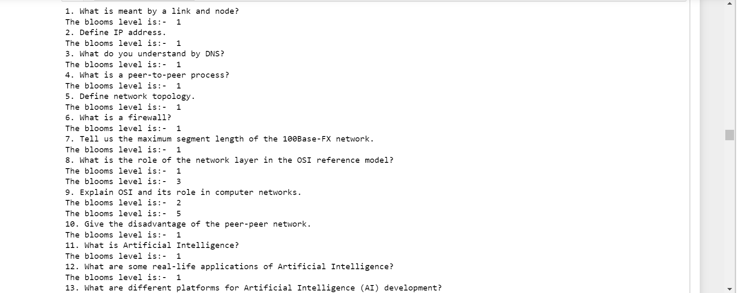

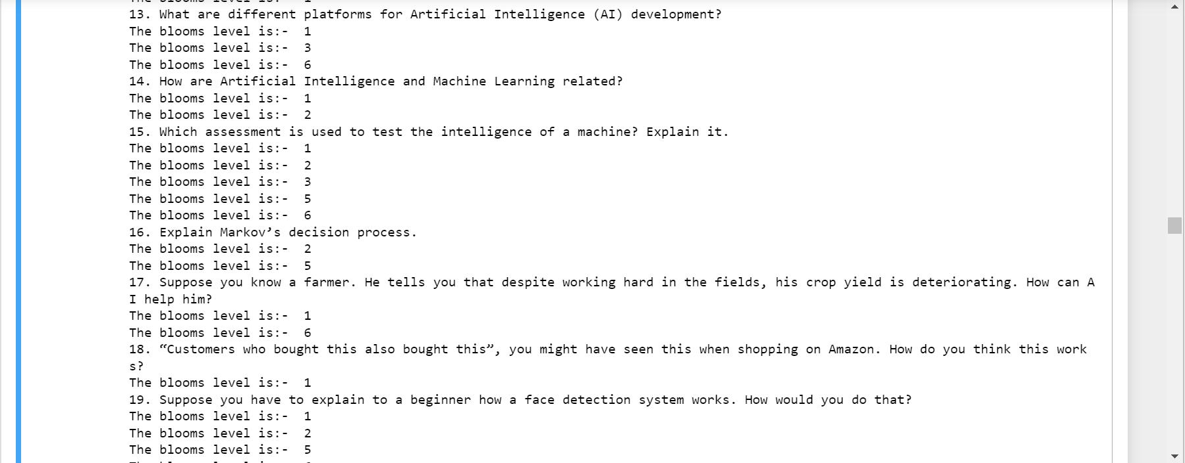



# **2.2 Multinomial Naive Bayes**

Multinomial Naive Bayes (MNB) is a type of Naive Bayes classifier that is suitable for classification of documents, particularly text. It has been successfully used in a variety of document classification tasks such as spam filtering, text categorization, sentiment analysis, and document categorization.

MNB uses a bag-of-words approach to represent documents, where each document is represented as a vector of word counts. Each word in the document is considered a feature, and the number of times a word appears in the document is the value of the feature. The goal of MNB is to classify a document based on the features and their values.

To apply MNB to question paper analysis, each question paper would be represented as a vector of word counts and the MNB classifier would be trained to classify the papers into different categories. For example, the classifier could be trained to differentiate between papers that contain multiple choice questions and those that contain essay type questions. After training, the classifier would be able to accurately classify new question papers into the appropriate category.

Algorithm

Read data

Capture unique data

Features= data[“Questions”]

Labels=data[“Blooming level”]

Declare a dictionary assigning values for each blooms level

Map data according to respective levels

X=data[“Questions”]

Y= data[“Blooming level”]

Spilt the data into train and test data

Transform the text data to feature vectorsthat can be used as input to the logistic regression

Implement multinomial naïve bayes classification on the data

get_value(levels,model.predict(feature_extraction.transform([input(“enter ur question”])

OUTPUT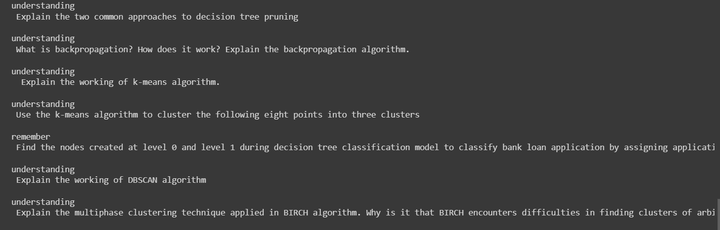

# **3.Discussions**

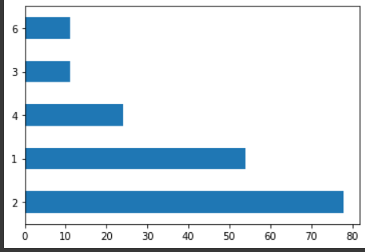

The levels referring to blooms taxonomy

|  |  |
| --- | --- |
| Create | 6 |
| Evaluate | 5 |
| Analyze | 4 |
| Apply | 3 |
| Understand | 2 |
| Knowledge | 1 |

So, we have given a data set of questions and it analysed the respective blooms taxonomy level of each question.

From the analysis we can see that maximum of the questions are from the second level (Understand) and minimum from the third level(Apply) and no questions from the level (Evaluate) from the data set given .

# **4.Concluding Remarks**

The analysis of blooms taxonomy has been beneficial to better understand the different levels of learning and their importance in the learning process. This analysis has provided a better understanding of how to recognize and apply the different levels of learning in the classroom.

This analysis can be used to develop instruction, assessment, and curriculum to ensure that the learners are able to reach their learning goals. Moreover, this analysis has helped in identifying and targeting the areas of learning that need to be improved in order to achieve better results.

In conclusion, the analysis of blooms taxonomy helps to make better use of cognitive processes while developing instruction. It helps to recognize the different levels of learning and the importance of each learning level. Moreover, it helps to identify areas that need to be improved in order to achieve better learning outcomes.

# **5.Future Work**

Future work in question paper analysis using Bloom's Taxonomy could include using natural language processing to build automated question analysis systems. These systems could take in raw text from a question paper and analyze it to determine the taxonomic level of each question. The system could also be used to detect common errors and mistakes in question papers, such as the use of leading questions or the use of overly difficult words. Further improvements could include adding the ability to detect implicit questions and identify the context in which a question was asked. Additionally, the system could be used to identify the most effective types of questions for various learning objectives

# **References**

1. Anderson, L. W., & Krathwohl, D. R. (2001). A taxonomy for learning, teaching, and assessing: A revision of Bloom’s taxonomy of educational objectives. New York, NY: Longman.

2. Bloom, B. S. (1956). Taxonomy of educational objectives, the classification of educational goals, Handbook I: Cognitive domain. New York: Longman, Green.

3. Herrmann, J. E., & Caruso, J. B. (2008). Applying Blooms Taxonomy in the Classroom. Education, 128(4), 522-529.

4. Smith, M. K. (2012). A brief history of the development of Bloom's Taxonomy. The International Journal of Educational & Psychological Assessment, 11(1), 1-10.

5. Moursund, D., & Bielefeldt, T. (1999). Applying Bloom's Taxonomy to the analysis of educational objectives and tests. Educational Measurement: Issues and Practice, 18(1), 5–10.